S.P.A.C.E Satellite Simulation User Guide

Contents
What is S.P.A.C.E? 2
Quick Recap 2
Getting Started 2
What you need 2
How to set it up 2
The Main Screen 4
Buttons and Controls 4
Adding Satellites 6
Adding TLEs 6
Extra Features 7
Typical Use 8
Troubleshooting (Simple Fixes) 8
TLE Display Behavior Tests 8

What is S.P.A.C.E?
S.P.A.C.E is a computer program that shows satellites moving around the Earth. You load in satellite information files (called TLEs), and the program displays the Earth and those satellites in a 3D window. It’s designed to make exploring satellite movements simple and visual.

Quick Recap
To summarise, S.P.A.C.E provides a visual and interactive way to explore satellites in orbit. The globe serves as the central view; the slider and the buttons control time. By adding satellites through TLE files, users can visualise orbits and toggle satellites on or off. Ground stations expand the simulation’s functionality, making it more than just a satellite viewer — it becomes a full satellite tracking and communication visualisation tool.
- The globe is your main view.
- Use the slider and buttons or shortcuts to control time.
- Load satellites to see them orbiting Earth.
- Orbit paths, ground stations, and menus make the experience more interactive.

Getting Started

What you need
- Python 3.12 (a program language tool the app is built on)
- GitHub Desktop (to download the program)

How to set it up
- Download the program from GitHub: https://github.com/samhallSwin/SPACE.
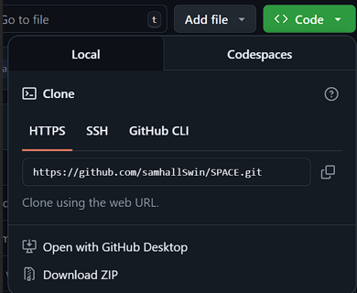
- Open the project and set up a Python environment (a safe “space” for the app to run).
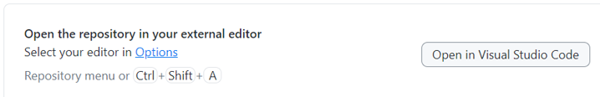
- Install the required packages (the app will list what it needs).
- Run the program — the main window will open and show a globe of the Earth.
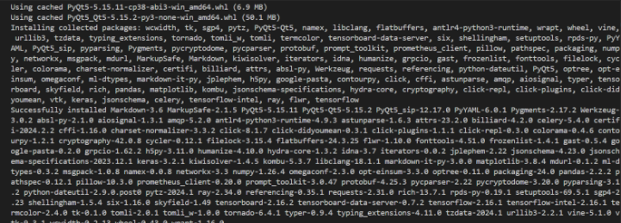
For more information check ‘Setting up Dev for satellite simulation GUI project’ documentation by Kartik Punna.

The Main Screen
When you open S.P.A.C.E, the main screen is dominated by a 3D globe of Earth. Along the bottom are a slider and buttons that let you manipulate the time of the simulation. Two hidden side panels: the one on the left can expand to provide satellite management options, where loaded satellites can be shown, hidden or deleted; and the one on the right can expand to show graphs that depict the adjacency matrix and connections between satellites. Satellites appear as dots orbiting Earth, and orbit lines trace their paths in real time.
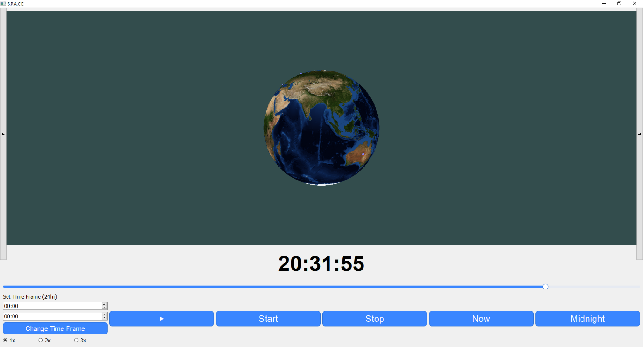
Figure 1: Main screen showing Earth with orbit paths and satellites in motion.
When you open the app, you’ll see:
- A Globe of the Earth in the middle with a texture map.
- Clock buttons at the top: Start, Stop, Now, Midnight.
- A Slider along the bottom to update the time.
- A Side Panel (on the right) to manage satellites you load.

Buttons and Controls
The control system in S.P.A.C.E is designed to be intuitive. The four clock buttons — Start, Stop, Now, and Midnight — allow you to control time within the simulation. For example, pressing Start begins the simulation and satellites move along their orbits, while Stop freezes the display. Now resets the simulation to real-world time, and Midnight jumps the display back to 00:00.
Using your mouse, you can rotate around the earth by dragging while holding the left mouse button, giving you a complete global view; zoom by using the scroll wheel; highlight and label satellites by hovering over them; and optionally show/hide their orbits with a right click whilst hovered. In addition, keyboard shortcuts make interaction faster: pressing the spacebar starts or stops the clock, “N” sets the time to Now, and “M” resets to Midnight.
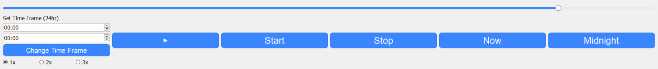
Figure 2: Time display and clock control buttons (Start, Stop, Now, Midnight).
Clock Buttons
- Play: Plays an animation of the satellites moving through the time frame.
- Start → Starts the clock so time moves forward in the app.
- Stop → Stops the clock and freezes the view.
- Now → Jumps the clock to the current real-world local (Melbourne) time.
- Midnight → Resets the clock to 00:00 (start of day).
Slider
- Moving the clock sliders moves forward or backwards in the listed time frame.
Globe
- Shows Earth with a texture (a map).
- Satellites appear as white/grey dots with orbit lines when you load them.
- Ground stations appear as purple orbs on the surface of the globe.
Keyboard Shortcuts
- Spacebar → Start/Stop clock
- N → Jump to Now
- M → Midnight reset
Mouse Buttons
- Left Mouse Button → Pan
- Mouse Wheel → Zoom
- Right Mouse Button → Show/Hide Orbits
- Middle Click → Centre Camera on Satellite (WIP)

Adding Satellites
A key feature of S.P.A.C.E is the ability to load satellites from TLE files. By expanding the left panel and dragging a TLE file into the section that says “Drag Here”, you can import one or more files. Once loaded, satellites are listed in the side panel where each one has a checkbox to toggle visibility. Users can also delete satellites and click the down arrow once or twice to show more information about the satellite. When satellites are loaded, orbit lines are automatically drawn, giving a clear representation of their paths over Earth.
This functionality makes the simulation flexible, allowing you to track multiple satellites at once and focus on specific ones depending on your interest or project needs.
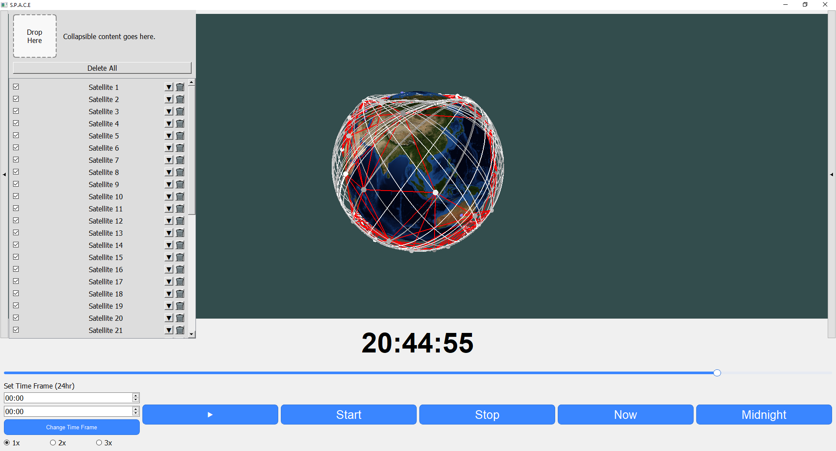
Figure 3: Side panel displaying multiple satellites with orbit paths and ground stations.

Adding TLEs
- Dragging a valid TLE file into the ‘Drop Here’ box (known as DropLabel in code) immediately loads all the satellites in the file into the simulation.
- Once loaded:
  - The satellites appear in a list on the left.
  - Each satellite has a checkbox to show/hide it.
  - You can delete a satellite from the list.
- Orbit paths are automatically drawn for loaded satellites.
- Adjacency between satellites and ground stations are drawn with a red line.

Extra Features
In addition, these are some of the extra features that can be added to the satellites and orbit paths in the future, S.P.A.C.E includes several advanced features that enhance its usefulness. Orbit lines make it easy to see how satellites move around the globe over time. Ground stations can be placed on Earth’s surface. This is particularly useful for visualising communication links and satellite-ground interactions.
• Orbit paths: show the lines satellites travel along.
• Ground stations (early version) : appear on Earth
• Keyboard shortcuts : quick access to clock and time controls.
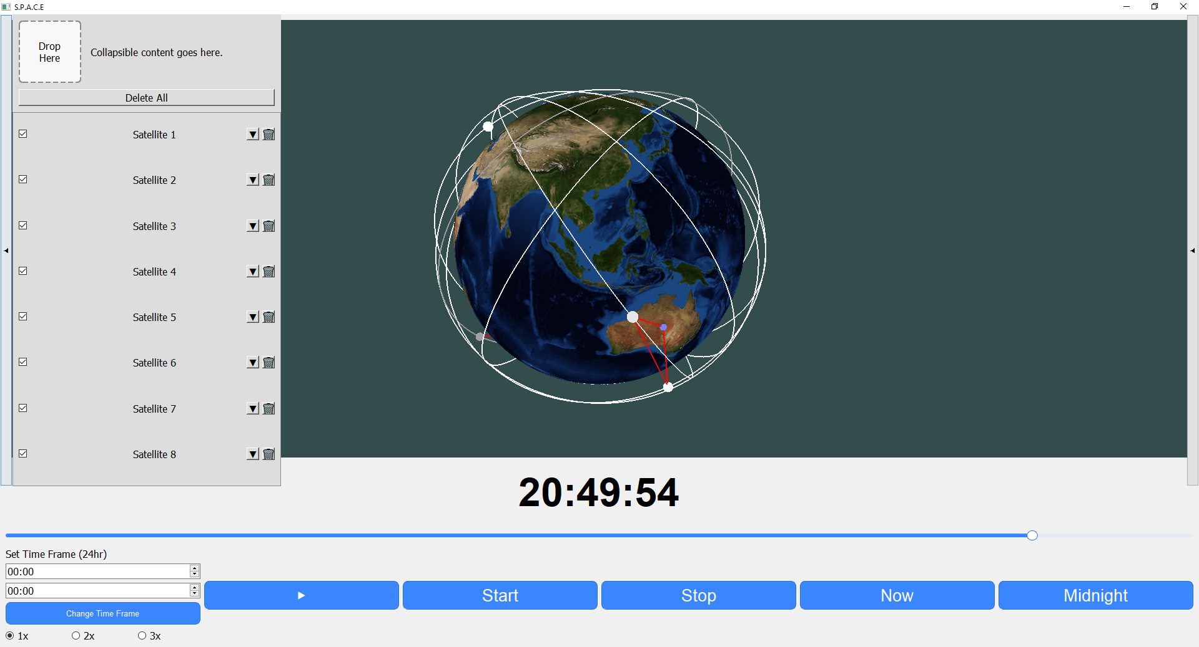

Typical Use
This step-by-step process allows users to simulate and explore satellite behaviour in a realistic and engaging way.
- Open the program.
- Load in satellites (using Add TLE or drag-and-drop).
- Check the satellites you want to see.
- Use the Start/Stop/Now/Midnight buttons to change time.
- Drag the slider to spin the Earth.

Troubleshooting (Simple Fixes)
If S.P.A.C.E does not start, the most common cause is an incomplete installation. Closing and reopening the program after reinstalling packages usually solves the issue. If the globe appears black, updating your computer’s graphics drivers generally fixes the problem. In cases where satellites do not display properly, it is often due to invalid or corrupted TLE files. Ensuring that the files are formatted correctly before importing prevents most loading errors. These simple fixes ensure the program remains accessible and easy to use, even for beginners.
- If the program won’t start: Make sure it was installed correctly. Try closing and reopening.
- If the globe is black: Update your computer’s graphics drivers. (Fixed in latest release.)
- If satellites don’t load correctly: Check that your TLE file is valid and formatted properly.

TLE Display Behaviour Tests
Two additional GUI integration tests were added to verify correct DropLabel functionality when the collapsible panel is toggled.
Test File: test_tle_display.py
Framework: Pytest + PyQt5 (qtbot)
Purpose:
- Ensures the DropLabel correctly disables drag-and-drop when the TLE Display panel is collapsed.
- Validates that the DropLabel re-enables drag-and-drop functionality when the panel is expanded again.

